KINGDOM OF SAUDI ARABIA | JAZAN UNIVERSITY

**COLLEGE OF COMPUTER SCIENCE & INFORMATION TECHNOLOGY**

**LAB Exam 2022-2023, Second Semester**

|  |  |  |  |
| --- | --- | --- | --- |
| Academic Year | 2022 -2023 | Total Marks | 20 |
| Course with code | ITEC-252- Digital Design & Computer Architecture, LEVEL-4 | Section | **2051** |
| Date of EXAM | 7-2-2023 | Duration | 24 hrs. |
| **STUDENT NAME:** |  | **STUDENT ID:** |  |

1. Use Logisim to draw the circuit diagram and write the truth table of the 3-to-8 Line Decoder using AND gate.

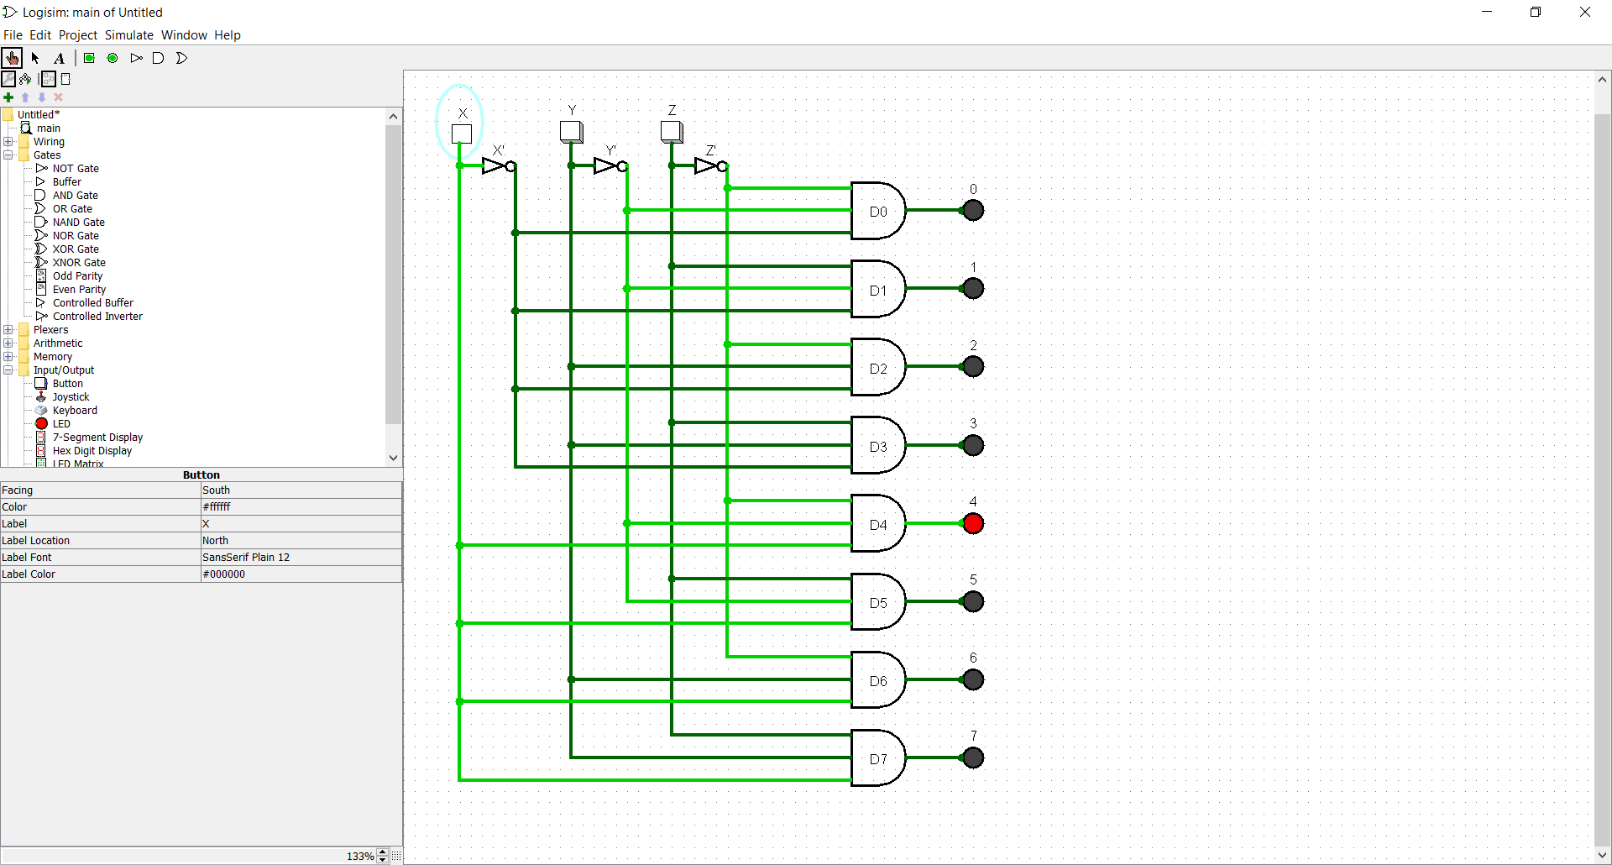

Here's the truth table for a 3-to-8 line decoder:

|  |  |  |  |  |  |  |  |  |  |  |
| --- | --- | --- | --- | --- | --- | --- | --- | --- | --- | --- |
| Input X | Input Y | Input Z | Output D0 | Output D1 | Output D2 | Output D3 | Output D4 | Output D5 | Output D6 | Output D7 |
| 0 | 0 | 0 | 1 | 0 | 0 | 0 | 0 | 0 | 0 | 0 |
| 0 | 0 | 1 | 0 | 1 | 0 | 0 | 0 | 0 | 0 | 0 |
| 0 | 1 | 0 | 0 | 0 | 1 | 0 | 0 | 0 | 0 | 0 |
| 0 | 1 | 1 | 0 | 0 | 0 | 1 | 0 | 0 | 0 | 0 |
| 1 | 0 | 0 | 0 | 0 | 0 | 0 | 1 | 0 | 0 | 0 |
| 1 | 0 | 1 | 0 | 0 | 0 | 0 | 0 | 1 | 0 | 0 |
| 1 | 1 | 0 | 0 | 0 | 0 | 0 | 0 | 0 | 1 | 0 |
| 1 | 1 | 1 | 0 | 0 | 0 | 0 | 0 | 0 | 0 | 1 |

1. Use Logisim to simulate the figure below and write the expression for the Boolean Function. Verify the circuit operation and fill in its truth table.

(-A&B) xor (A | C)

|  |  |  |  |  |  |
| --- | --- | --- | --- | --- | --- |
| A | B | C | (-A & B ) | (A | C) | Output |
| 0 | 0 | 0 | 0 | 0 | 0 |
| 0 | 0 | 1 | 0 | 1 | 1 |
| 0 | 1 | 0 | 1 | 0 | 1 |
| 0 | 1 | 1 | 1 | 1 | 0 |
| 1 | 0 | 0 | 0 | 1 | 1 |
| 1 | 0 | 1 | 0 | 1 | 1 |
| 1 | 1 | 0 | 0 | 1 | 1 |
| 1 | 1 | 1 | 0 | 1 | 1 |

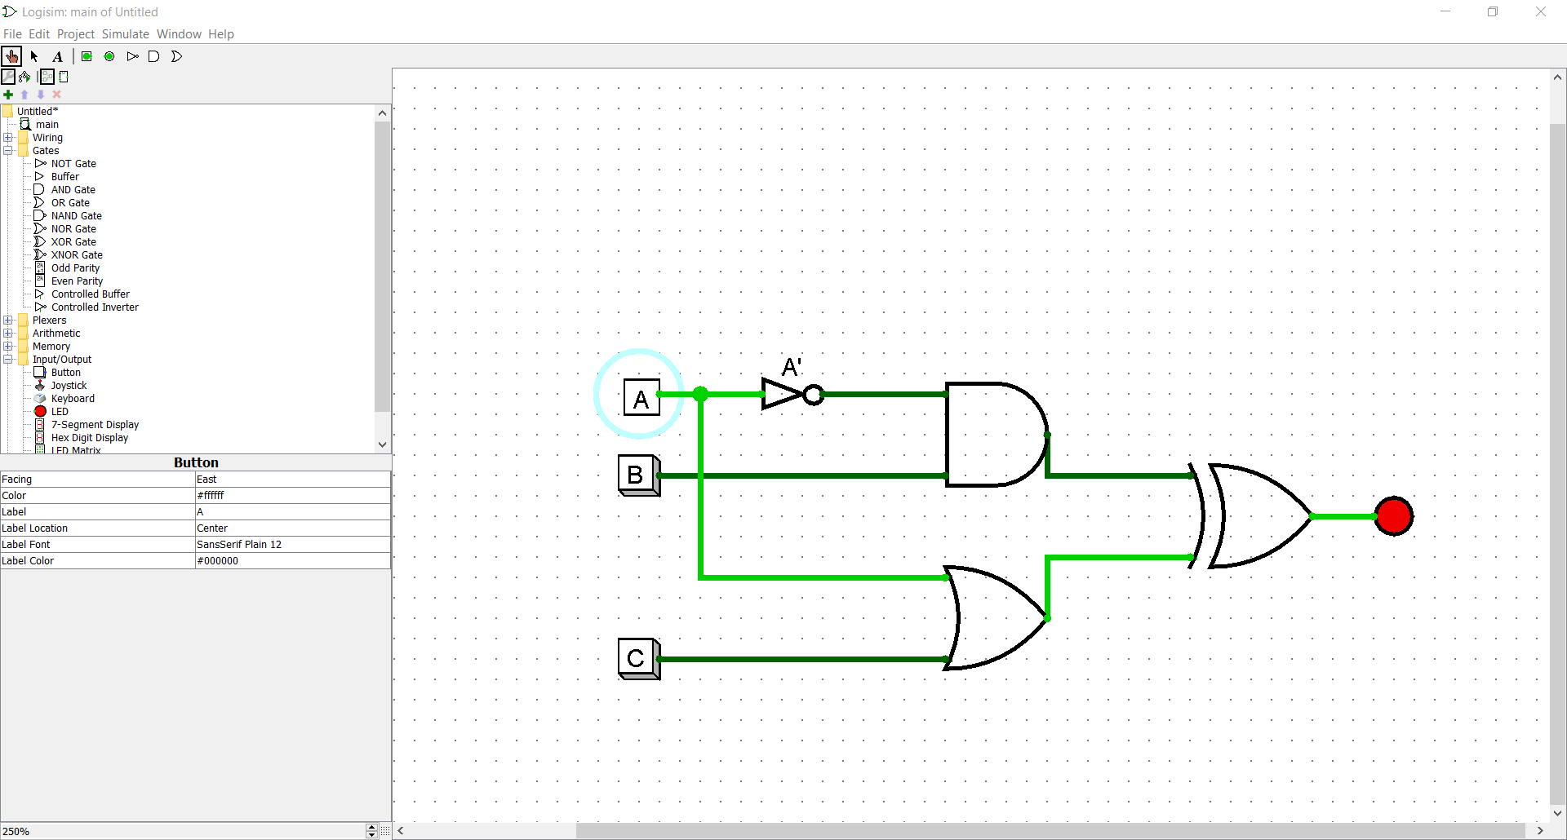

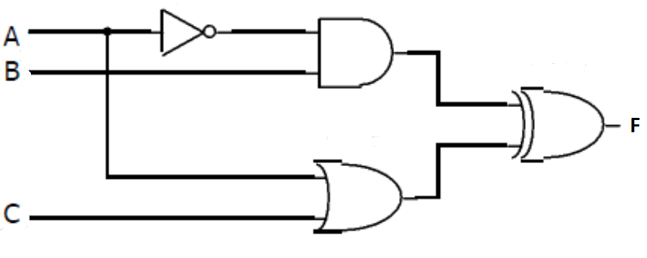

1. Use Logisim software to simulate the figure below.

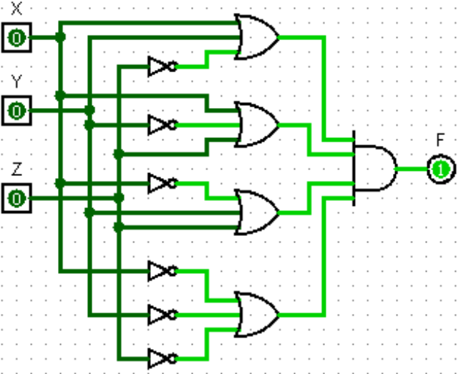

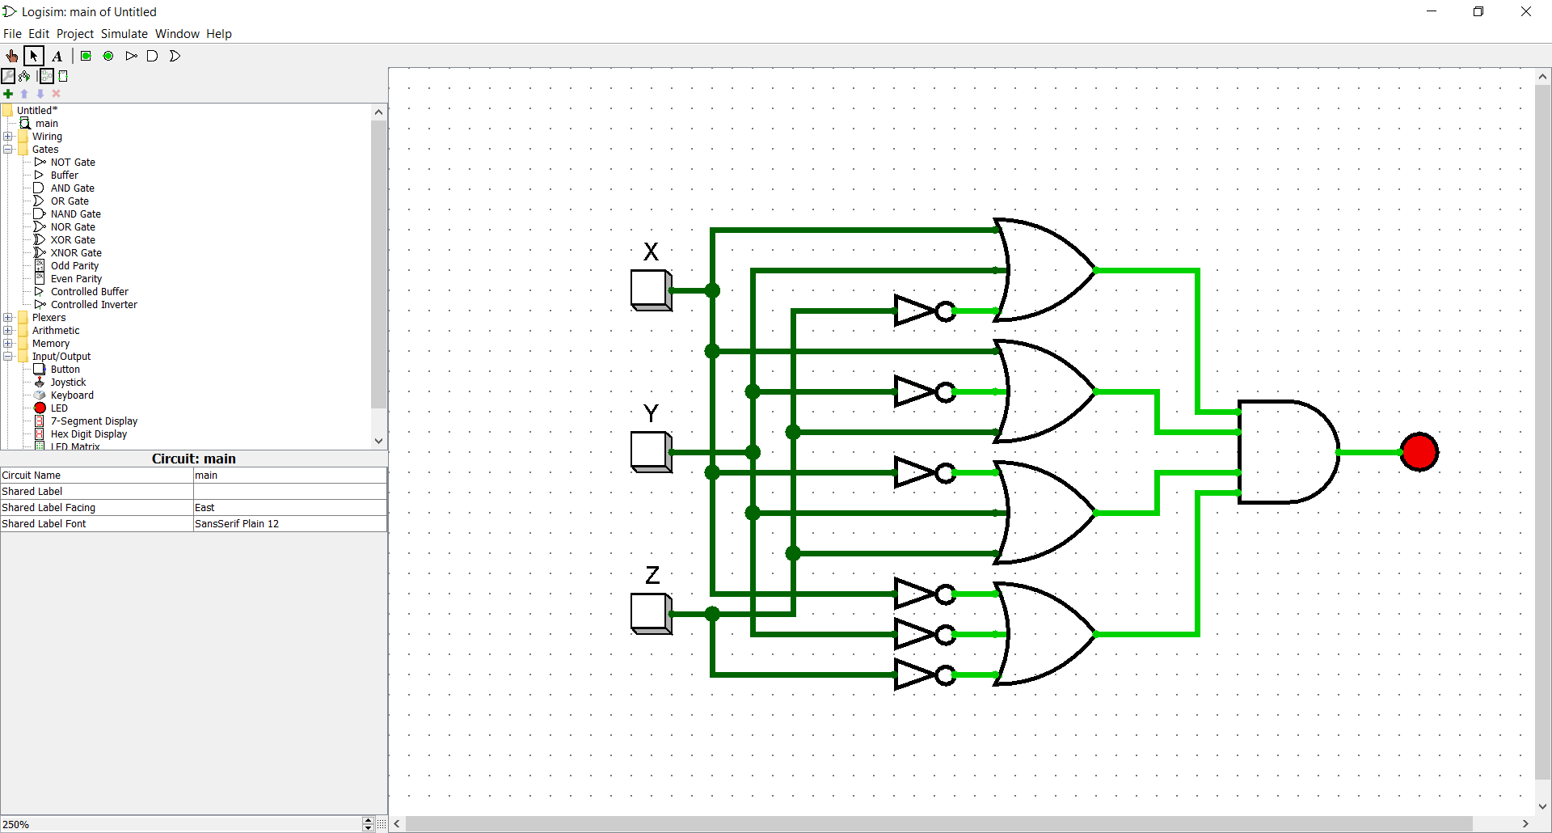

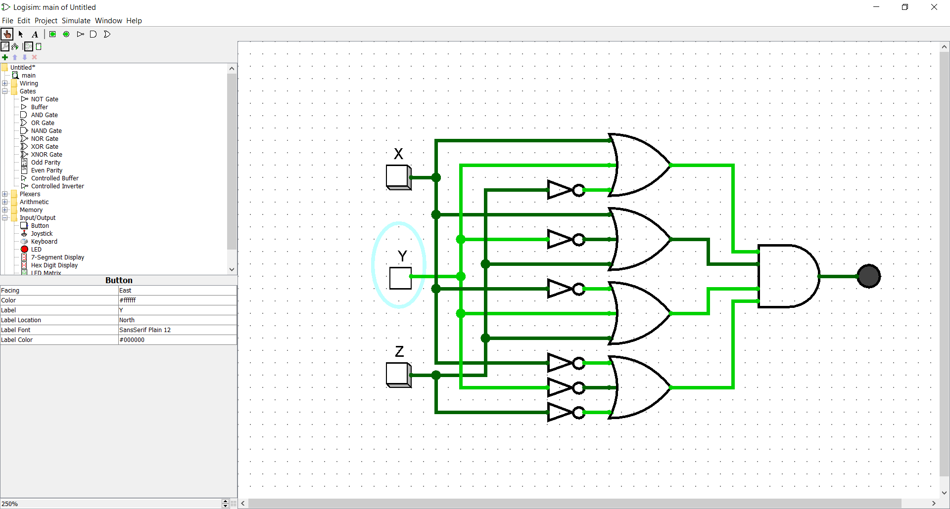

1. **Using Logisim software to the draw circuit diagram for the following equation:**

***K= $m^{'}w+{mw}^{'}$***

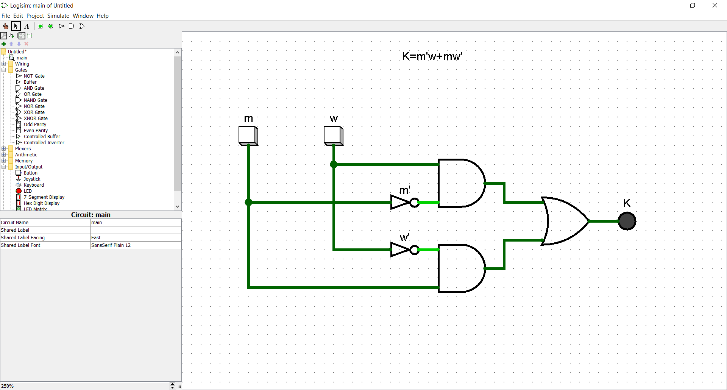

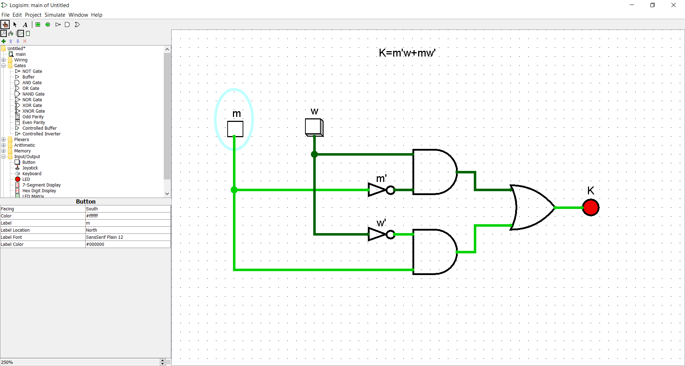

1. **Using Logisim software to the draw circuit diagram for the following equation:**

***Y= ${(A+B)(B+C)(A+C}^{'})$***

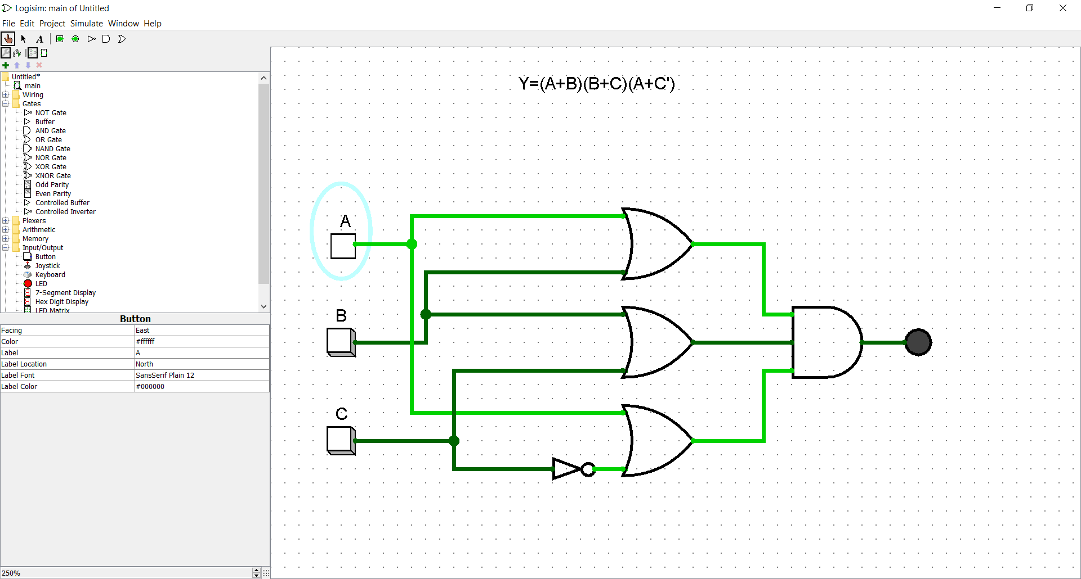

1. **Use Logisim software to simulate the figure below and write the expression for the Boolean Function for both F1 and F2.** 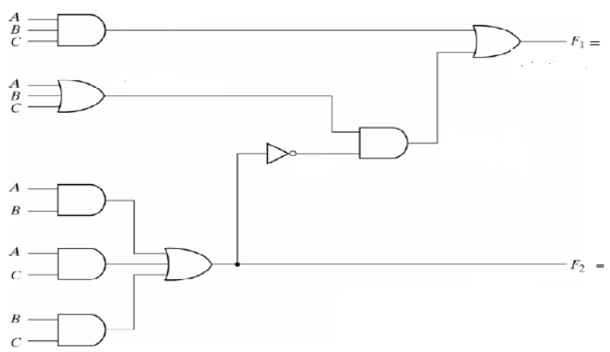

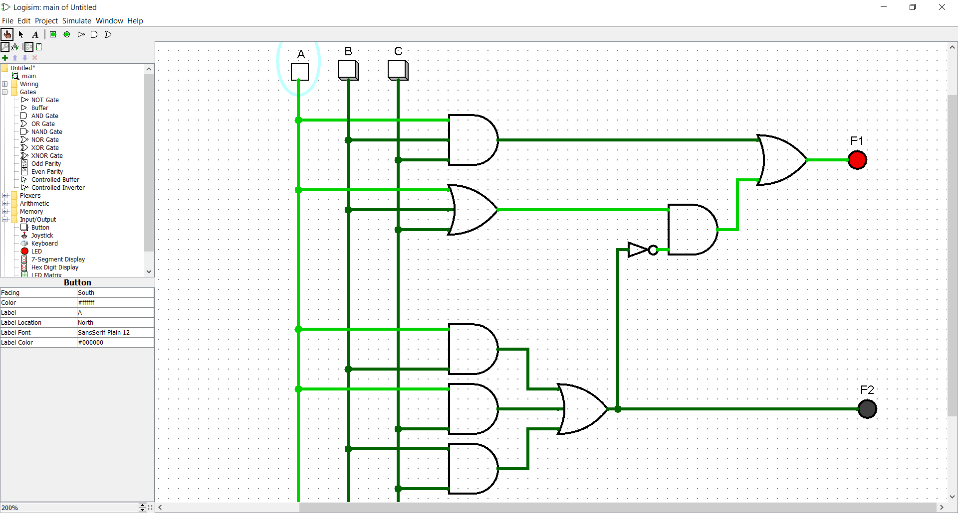

*Goodluck*

==================================================================

***Instructions:***

* Upload the implementation file from Logisim for each question *(by the name of the question).*
* The screenshots of all the simulations must be included.
* Complete the tasks and submit the task (implementation files) on Blackboard in time.
* Include snapshots from your simulations in your answer sheet for each question.
* Do not submit via email or WhatsApp.
* Cheating will be detected by Plagiarism software and will cause a deduction in marks.